**17) Create a visual representation in Figma illustrating the operation of proactive and reactive routing protocols in mobile IP.**

**Aim:**

Create a visual representation in Figma illustrating the operation of proactive and reactive routing protocols in mobile IP.

Procedure:

1. Define Presentation Structure
2. Create a Figma Project
3. Design Visual Elements
4. Make it Interactive
5. Add Annotations and Explanations
6. Incorporate Multimedia
7. Storyboard Animation
8. Test the Prototype
9. Collaborate and Gather Feedback
10. Finalize and Share

**Step By Step Procedure :**

**Interface Of Experiment:**

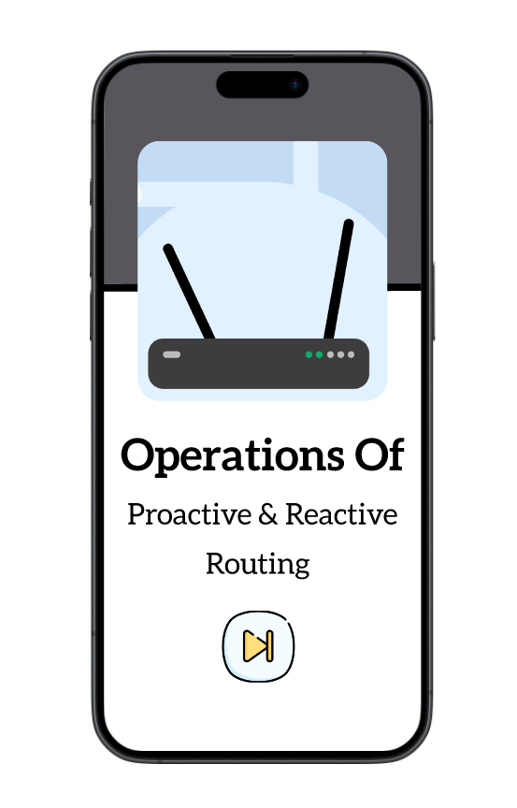

**Next Page:**

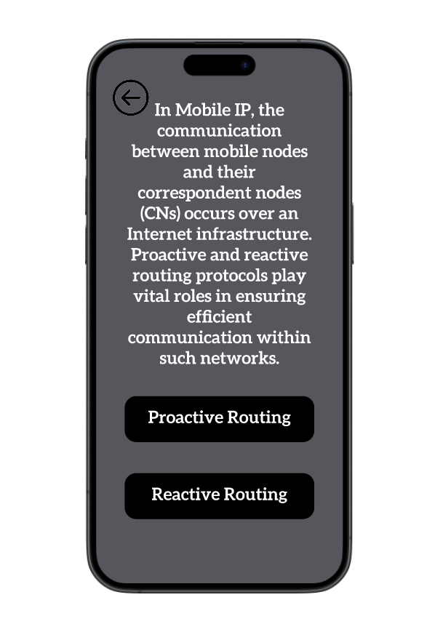

**Final Step:**

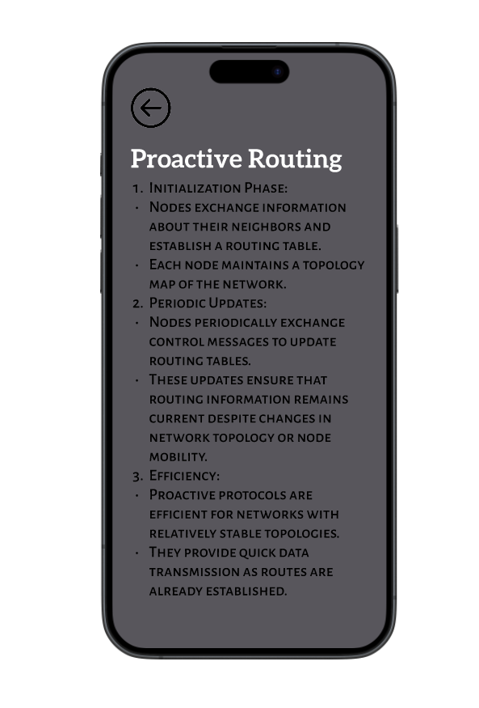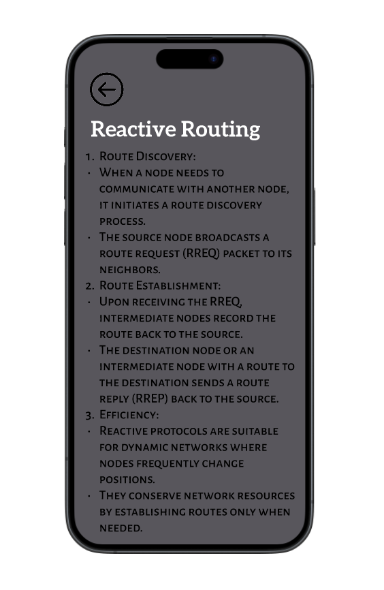

**Prototype:**

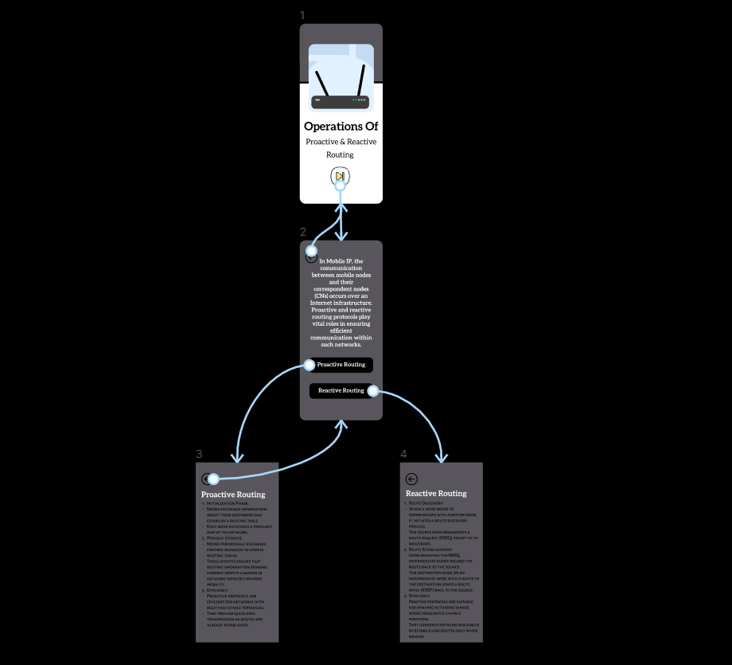

**Result:**

Hence the illustrating the operation of proactive and reactive routing protocols in mobile IP is created and executed successfully